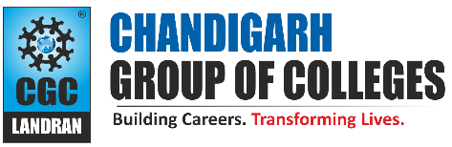
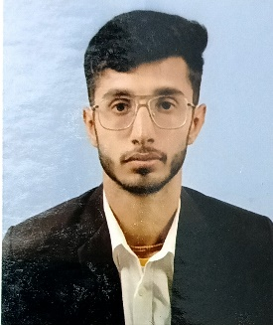
Paste Your Photograph Here

Mayank
[201, Thakar Basti, Fatehabad, Haryana] [125050]
[9255489212]
[katariamayank004@gmail.com]
[www.linkedin.com/in/mayank-kataria-0a5681282].

PROFESSIONAL SUMMARY

A well-organized, creative and goal-oriented under-graduate possessing excellent communication, problem-solving and leadership skills with a flair to explore suitable avenues in Electronics and Communication Engineering while developing advanced projects with efficiency and quality.

TECHNICAL COMPETENCIES
OS: Windows
Languages: C | Python | HTML | CSS
Databases: MySQL
Other Interests: Software Engineering, web development.

INTERPERSONAL SKILLS
Team Leadership | Management & Coordination | Decision Making & Analytical Skills | Speaking and Writing Skills | Time Management.

INTERESTS & HOBBIES
Web Series | Movies | Badminton | Cricket| Travelling.

LANGUAGES KNOWN
English | Hindi | Punjabi

PERSONAL DETAILS
Mother’s Name: Mrs. Pooja
Father’s Name: Mr. Manoj Kumar
D.O.B: 20/07/04

EDUCATION
Bachelors of Technology in Electronics and Communication Engineering | Chandigarh Group of Colleges, Landran
Session: 2022-2026 | CGPA: 7.0
Intermediate (CBSE) | Daffodils Public School, Fatehabad
Session: 2021-2022 | Percentage: 80%
Matriculation (CBSE) | Crescent Public School, Fatehabad
Session: 2019-2020 | Percentage: 86.4%

TRAINING & PROJECTS
- Project Name: Smart and Efficient Borewell Rescue Operation System
Duration: 45 Days
Environment: Windows
Languages/Database: Arduino
Team Size: 3
- The project is engineered to efficient rescue individuals trapped in borewell with the aid of medical support.
- Project Name: Student Management System
Duration: 15 Days
Environment: Windows
Languages/Database: Python/MySQL
- A student management system is designed to record, analyze, and manage information in a school, colleges, universities and other educational fields.

ACADEMIC ACHIEVEMENTS
- Participated in Parivartan Techno-cultural Fest (Project Display) (2023) in Chandigarh Group of Colleges, Landran & secured the 2nd Position.
- Participated in Symposium of Innovation (Project Presentation) (2023) in Chandigarh Group of Colleges, Landran & secured the 1st Position.
- Filed Patents under Intellectual Property India (Government of India) Application No. 202411042787, 202411103055, 202411103054, 202511004616, 202511004953.

CERTIFICATIONS
- Studied Digital Circuits from Swayam NPTEL.
- Studied Python Fundamentals for Beginners from Great Learning.
- Attended HTML CSS Bootcamp from LetsUpgrade.

EXTRA CURRICULAR & CO-CURRICULAR ACHIEVEMENTS
- ECE Student Coordinator of Institution’s Innovation Council.
- President of Techcomm Professional Society of the college.
- Coordinator in Parivartan Techno Cultural Fest (2022).
- Participant in Project Display in National Science Day (2023) and (2024).
- Participant in Smart India Hackathon 2023 and 2024.
- Participant in Inno-Tech 2k24 by Pushpa Gujral Science City (2024).
- Coordinator in 5th International Conference ICCS 2k24.
- Coordinator in Electrofusion 2k24.
- Organized Thrust 2k24 at Chandigarh Group of Colleges, Landran.
- Organized Parivartan Techno Cultural Fest 2k24.

